**H)** **Preliminary Component Selection**

**MOSFET :** IRF540

While choosing the mosfet, the drain to source voltage and the drain current of the mosfet is examined in the simulation and both of them are illustrated in Figure X. The drain to source voltage of the mosfet doesn’t exceed 50V and the Mosfet current is at maximum 10A. We added a safety margin and chose our mosfet. The chosen mosfet has the following properties :

VDSS = 100V

ID = 23A.

The datasheet of the chosen mosfet is : <http://pdf1.alldatasheet.com/datasheet-pdf/view/17799/PHILIPS/IRF540.html>

Thus, the chosen mosfet satisfies the requirements of our design.

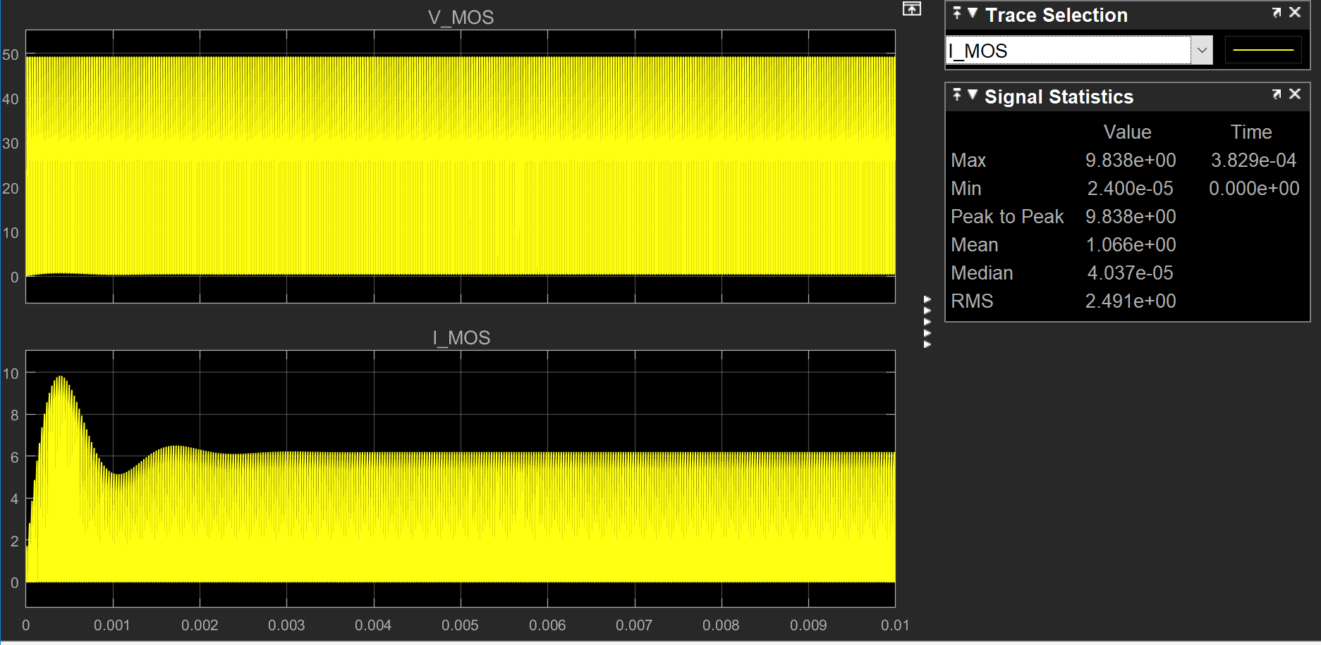

Figure X – Voltage and the current waveforms of the mosfet.

**Diodes**

* **Diode 1 :** BYW77PI100

The current and the voltage on the diode 1 is illustrated in Figure X. While choosing the diode, forward voltage drop, repetitive reverse peak voltage and the forward current parameters are examined. The chosen diode has the following properties :

VF = 1 V

VRRM = 100 V

IF = 50 A

The diode voltage is about 30 V and the diode current has a maximum of 7 A. Regarding the specs of the chosen diode, the diode meets the requirements of the simulation results.

The other parameters of the diode is given in the datasheet of the diode and it is :

<https://img.ozdisan.com/ETicaret_Dosya/2296_9235280.pdf>

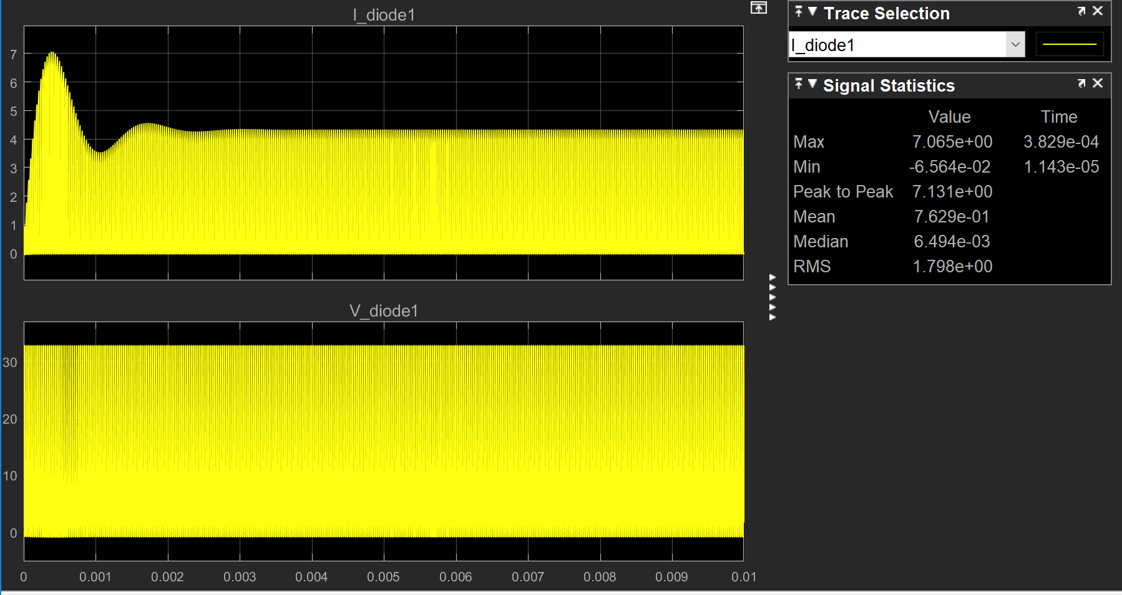

Figure X – Voltage and the current waveforms of the diode 1.

* **Diode 2 :** BYW77PI100

The diode 2 has the same properties with diode 1 and it is illustrated in Figure X.

Thus, the same diode chosen for diode 1 will also be used for the diode 2.

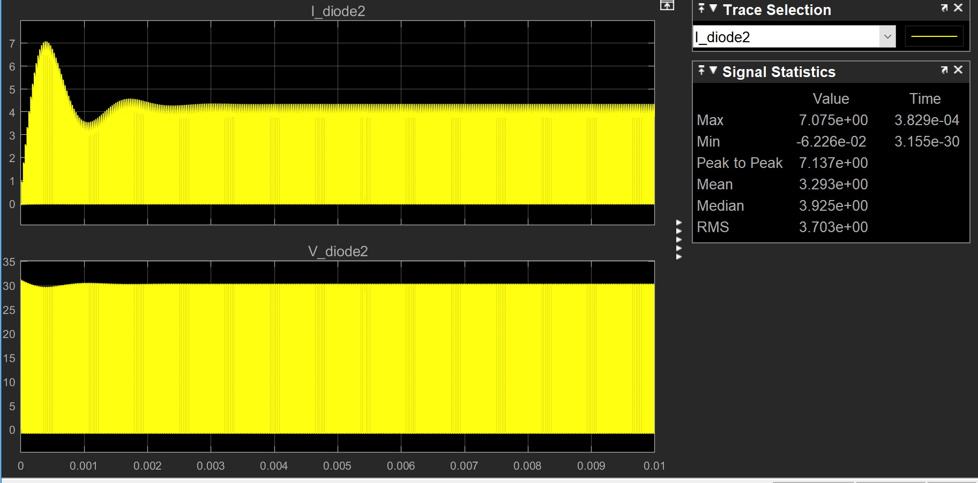

Figure X – Voltage and the current waveforms of the diode 2.

* **Diode 3 :** BYW77PI100

The diode 3 has a greater voltage on it compared with diode 1 and diode 2 as illustrated in Figure X.

Hovewer, the chosen diode for diode 1 and diode 2 also satisfies the requirements of this diode. Hence, the same diode will be used for this diode too.

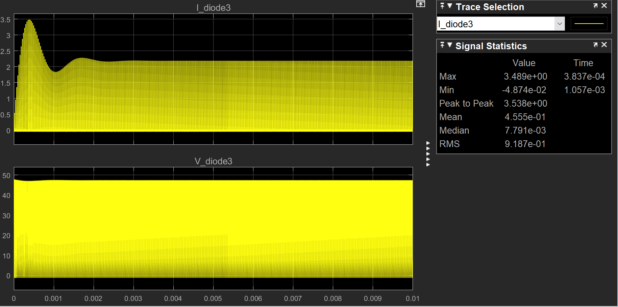

Figure X – Voltage and the current waveforms of the diode 3.

**Capacitor :** [PKRM-050V101MF115-T/A5.0](https://www.ozdisan.com/pasif-komponentler/kondansatorler/aluminyum-kondansatorler/PKRM-050V101MF115-TA5-0)

While choosing the electrolytic capacitor , the most important thing to consider is the voltage rating of the capacitor. As illustrated in Figure X, the voltage on the capacitor is the same as the voltage on the output, which is 12V. However, there may be some momentary voltage spikes on the capacitor. Hence, with an extra safety margin we chose the capacitor with 50 V rating.

The datasheet of the capacitor is :

<https://img.ozdisan.com/ETicaret_Dosya/28884_974931.pdf>

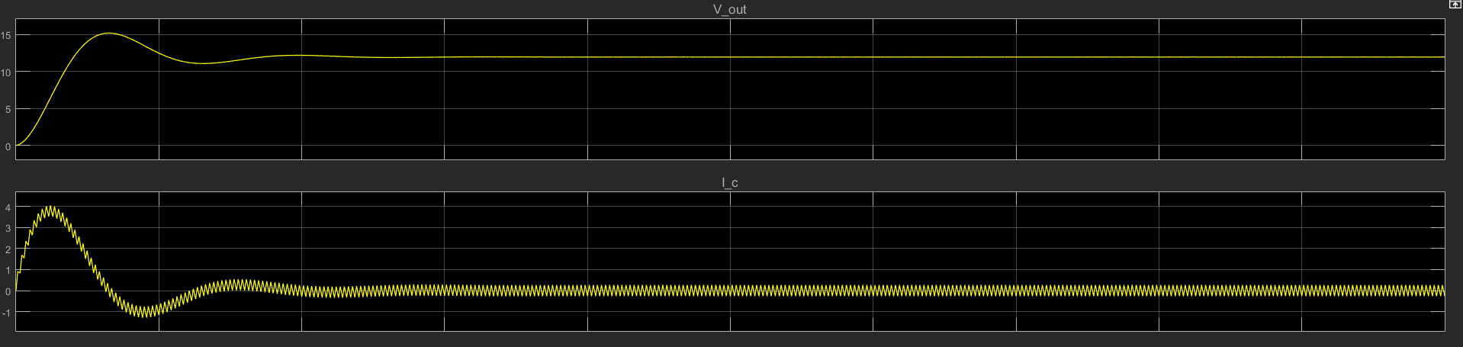

Figure X – Voltage and the current waveforms of the capacitor.

**Transformer**

* **Core :** 0P43434EC

The datasheet of the chosen core is : <https://www.mag-inc.com/Media/Magnetics/Datasheets/0P43434EC.pdf>

* **Wire :** 21-AWG Cable

Necessary justifications of the transformer core and the wire choice is given in part B.